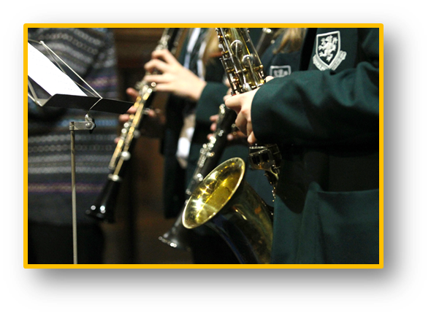
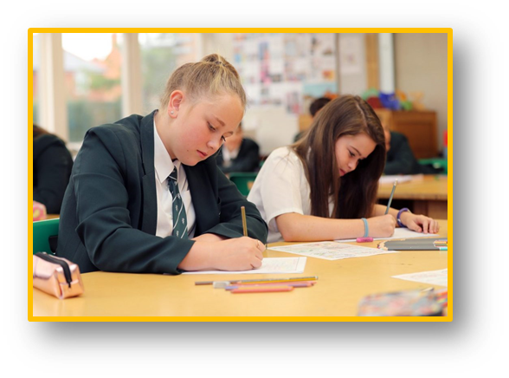
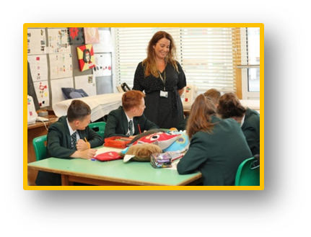

Job Application Pack

Darland High School
Teaching Assistant Level 1
Headteacher Joanne Lee
G03 £18,065 FTE
£10,948 pro rata
Full time (27.5 hrs per week),
Term Time only
Closing Date:
12:00 noon, Friday 31st July 2020
Interviews :
To be held on Thursday 6th August
Darland
High School

Letter from the Headteacher

Dear Colleague,

Thank you for your interest in working at Darland High School.
I am immensely proud to be the Headteacher here at Darland and I want everyone who comes to DHS to be an equally proud member of our family. Our work is about making a real difference to the lives of children so that they in turn make a discernible difference to their communities, our town and our world.
We serve a diverse community in North East Wales, ranging from high levels of disadvantage and deprivation to affluent areas of rural Wrexham, and we work as a team to provide all our students with the best education and opportunities to inspire them to be successful.
Our students are at the heart of everything we do at DHS, every child matters to us and we believe that every child can succeed. Our moto is ‘Aspire, Apply, Achieve’. Our expectations for academic standards and behaviour are therefore unapologetically high.
I was appointed as Headteacher in September 2019, and although all schools now find themselves in unchartered territory, we are undoubtedly on a journey of change with our sights set on becoming an excellent school. We have a dedicated team of over 135 staff who work together tirelessly with this goal in mind.
I look forward to reading your application.
Kind regards,

Joanne Lee
Headteacher

Application Details
Thank you for your interest in the post of ‘Teaching Assistant Level 1’ vacancy at Darland High School. We are looking for a passionate and driven individual to make a contribution to the current team at DHS.
Further details of this post can be found in this pack, details of the school can be found on our website which is currently being updated. Details of how to apply can be found below:

How to Apply
Should you wish to apply for the post, please complete and return the Wrexham Authority application form directly to the school along with a covering letter addressed to our Headteacher, Mrs. J Lee, which clearly demonstrates your suitability for this role.
Applications can be downloaded from our website and submitted via email to headteacher@darlandschool.org.uk with Application for Teaching Assistant in the subject line, or by post for the attention of Mrs Lee, to the following address:
Recruitment
Darland High School
Chester Road
Rossett
Wrexham
LL12 0DL
Please be aware that postal services may be delayed in the current climate. We recommend you email your application.

Application forms: These can be downloaded from the school website at https://darland.wrexham.sch.uk/vacancies/
Wherever possible, please provide email addresses for your referees.
Closing Date: Please ensure your application arrives by 12:00 noon on the closing date of
Friday 31st July 2020
Interview: Interviews will be held on Thursday 6th August

Safeguarding: Darland High School is committed to safeguarding and promoting the welfare of children and young people. We expect all staff and volunteers to share this commitment. As this post is subject to a DBS check, the Local Authority will require you to pay for the cost of this check, as part of the DBS application. You will also be required to register with the EWC prior to starting in post, for which there is also a fee.

Post: Teaching Assistant Level 1

Level 1—Grade G03 Job ID 1065
Please find the generic job description below with contextual interpretation of the specific role at Darland High School emphasised beneath each statement.

PURPOSE:

To work under the direct instruction of teaching/senior staff, usually in the classroom with the teacher, to support access to learning for pupils and provide general support to the teacher in the management of pupils and the classroom. To implement strategies to support individuals shared via Individual Education Plans/ Additional Needs Coordinator/ outside agencies. The successful applicant will be expected to work in a diverse way linked either to a department or to the Additional Needs Resource.

DIMENSIONS:
Darland High School is an English-medium secondary school in North East Wrexham. In September 2019 Joanne Lee was appointed as Headteacher. The Additional Needs Resource caters for a wide number of students who experience a range of barriers to their learning, predominantly difficulties associated with Dyslexia and Social Communications. We are looking for a confident and enthusiastic individual who enjoys working with pupils to help them succeed. Experience of working with teenagers and a keenness to learn / adapt to new systems and technology is desirable.

In light of the current circumstances please contact the Headteacher’s PA Mrs. Clare Pickup on headteacher@darlandschool.org.uk directly if you wish to have a tour of the site and a discussion about the role prior to the deadline (social distancing measures followed).

MAIN DUTIES AND RESPONSIBILITIES

SUPPORT FOR THE PUPILS

- Attend to the pupils’ personal and educational needs, and implement related person centred programmes, including social, health, physical, hygiene, first aid and welfare matters
- Supervise and support pupils ensuring their safety and access to learning
- Establish good relationships with pupils, acting as a role model and being aware of and responding appropriately to individual needs
- Promote the inclusion and acceptance of all pupils
- Encourage pupils to interact with others and engage in activities led by the teacher
- Encourage pupils to act independently as appropriate

SUPPORT FOR THE TEACHERS

- Prepare classroom as directed for lessons and clear afterwards and assist with the display of pupils work
- Be aware of pupil problems/progress/achievements and report to the teacher as agreed
- Undertake pupil record keeping as requested
- Support the teacher in managing pupil behaviour, reporting difficulties as appropriate
- Gather/report information from/to parents/carers as directed
- Provide clerical/admin. support e.g. photocopying, typing, filing, collecting money etc.

SUPPORT FOR THE CURRICULUM

- Support pupils to understand instructions
- Support pupils in respect of local and national learning strategies e.g. literacy, numeracy, KS3, early years, as directed by the teacher
- Support pupils in using basic ICT as directed
- Prepare and maintain equipment/resources as directed by the teacher and assist pupils in their use

SUPPORT FOR THE SCHOOL

- Be aware of and comply with policies and procedures relating to child protection, health, safety and security, confidentiality and data protection, reporting all concerns to an appropriate person
- Be aware of and support difference and ensure all pupils have equal access to opportunities to learn and develop
- Contribute to the overall ethos/work/aims of the school
- Ensure compliance with Darland High School Teaching Assistant’s Code of Conduct
- Appreciate and support the role of other professionals
- Attend relevant meetings as required, once weekly
- Participate in training and other learning activities and performance development as required
- Assist with the supervision of pupils out of lesson times, including before and after school and at lunchtimes
- Accompany teaching staff and pupils on visits, trips and out of school activities as required

CONTACTS

Headteacher
All Teaching/Non Teaching Staff
Pupils
Parents
Governors

WREXHAM COUNTY BOROUGH COUNCIL

PERSON SPECIFICATION

POST: TEACHING ASSISTANT – LEVEL 1 GENERAL

PURPOSE:

To work under the direct instruction of teaching/senior staff, usually in the classroom with the teacher, to support access to learning for pupils and provide general support to the teacher in the management of pupils and the classroom.

ITEM | ESSENTIAL | DESIRABLE
Qualifications | Good numeracy/literacy skills  Participate in development and training opportunities  GCSE grade C or above English and Maths
Experience | Working with or caring for children of relevant age
Knowledge and Skills | Appropriate knowledge of first aid  Use basic technology – computer, video, photocopier  Ability to relate well to children and adults  Work constructively as part of a team, understanding classroom roles and responsibilities and your own position within these | Knowledge of barriers to learning due to specific difficulties such as Autism, Dyslexia and ADHD

Signature:-

Postholder…………………………………….. Date………………………..

Headteacher…………………………………… Date ………………………..

