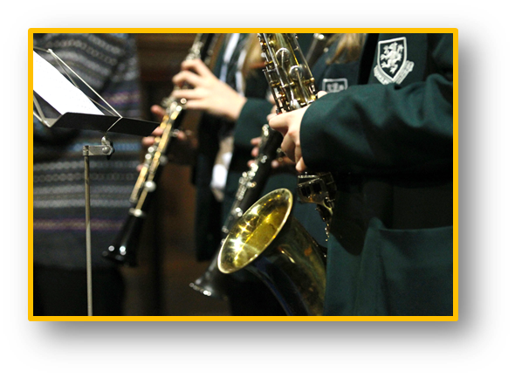
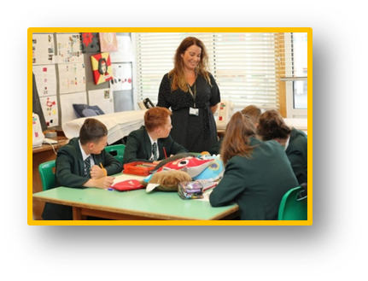

Job Application Pack

Darland High School
Office Administration Assistant (g0
Headteacher Joanne Lee
£18,198 — £18,562 FTE (GO3)
£14,838 - £15,135 pro rata
Full time (37 hrs per week)
Term Time only (38 weeks/year)
Closing Date:
12:00 noon, Friday 30th October 2020
Interviews will be held the following week
Darland
High School

Letter from the Headteacher

Dear Colleague,

Thank you for your interest in working at Darland High School.
I am immensely proud to be the Headteacher here at Darland and I want everyone who comes to Darland High School to be an equally proud member of our family. Our work is about making a real difference to the lives of children so that they in turn make a discernible difference to their communities, our town and our world.
We serve a diverse community in North East Wales, ranging from high levels of disadvantage and deprivation to affluent areas of rural Wrexham, and we work as a team to provide all our students with the best education and opportunities to inspire them to be successful.
Our students are at the heart of everything we do at DHS, every child matters to us and we believe that every child can succeed. Our moto is ‘Aspire, Apply, Achieve’. Our expectations for academic standards and behaviour are therefore unapologetically high.
I was appointed as Headteacher in September 2019, and although all schools now find themselves in unchartered territory, we are undoubtedly on a journey of change with our sights set on becoming an excellent school. We have a dedicated team of over 135 staff who work together tirelessly with this goal in mind.
I look forward to reading your application.
Kind regards,

Joanne Lee
Headteacher

Post Details
Thank you for your interest in the vacancy for an Office Administration Assistant at Darland High School. We are looking for a passionate and driven individual to work within the ‘hub’ of our school to support our school community of circa 810 students and 130 staff.

The successful applicant will join a small administration team based in the school Reception under the line management of the Heads P.A. We are looking for someone with good computer and communication skills who is able to work within a team as well as on their own. The post is based in a very busy office, so the successful post holder will be expected to be proactive and multi-skilled, with a “can do” attitude. An ability to use initiative and to prioritise work to meet deadlines is essential. Experience of working in a similar setting and knowledge of SIMS and InTouch would be beneficial to your application.

The post is term time only, with annual leave to be taken outside of term time. The hours of working are 8.10am – 4pm Monday to Thursday, with a 3.30pm finish on Fridays.
Please note that the successful applicant will be expected to undertake First Aid training, and to assist with first aid incidents on a rota with other staff at the school.
How to Apply
If you wish to discuss the role prior to applying, please contact the Headteacher’s P.A. Mrs. Clare Pickup on headteacher@darland.wrexham.sch.uk. For further details about Darland High School please visit our website https://darland.wrexham.sch.uk or look for our social media Tweets and Instagram posts.

To apply for the post, please complete and return the Wrexham Authority application form that can be downloaded from the Darland High School website (Non-Teacher Application Form required) and submit the form directly to the school along with a covering letter addressed to our Headteacher, Mrs. J Lee, which clearly demonstrates your suitability for this role. As postal services may be delayed in the current climate, we recommend you email your application to headteacher@darland.wrexham.sch.uk with “Office Administration Assistant” in the subject line. Alternative, please post your application for the attention of Mrs Lee, to the following address:
Recruitment
Darland High School
Chester Road
Rossett
Wrexham
LL12 0DL

Wherever possible, please provide email addresses for your referees.
Closing Date: Please ensure your application arrives by 12:00 noon on the closing date of
Friday 30th October 2020.

Interview: Interviews for the role will be held the following week
Safeguarding: Darland High School is committed to safeguarding and promoting the welfare of children and young people. We expect all staff and volunteers to share this commitment. As this post is subject to a DBS check, the Local Authority will require you to pay for the cost of this check, as part of the DBS application. You will also be required to register with the EWC prior to starting in post for which there is also a fee.

Post: Office Administration Assistant (G03) (ID 2506)

Section 1 : PURPOSE:

To provide a routine, general clerical administrative service to the school.
To answer and respond to all telephone calls coming into the school from parents and outside agencies.
Maintenance of confidential pupil data including the use of MIS packages for the purpose of gathering and selecting date for reporting purposes.
Collation of pupil reports in response to staff queries and letters for distribution to parents.

Assist with pupil welfare issues including looking after sick pupils, liaising with parents and staff.

Section 2 : DIMENSIONS

The post holder is required to work within a busy administration office and to undertake the day to day administration duties required to support an active school community of circa 850 students and approximately 130 staff.
The post holder is first port of call for all telephone calls to the school.
The post holder is first port of call for all visitors to the school.
The post holder is required to assist and liaise with staff in regard to pupil wellbeing and welfare, sickness and safe-guarding issues.
The post holder is responsible for the sale of stationary items to students and managing a float of approximately £20.00 for the school shop.
The post holder is responsible for the up-to-date maintenance of confidential pupil data and for the printing of “pupil reports” to be passed to teachers to give to pupils and also for sending copies to parents who do not live with the child.
The post holder is responsible for the safe key, master key to student lockers, meeting room keys, mini bus keys, key to student records room and key to the medical room.

Section 3 : PRINCIPAL DUTIES AND RESPONSIBILITIES

1 | Daily – To be the first point of contact for internal and external bodies by answering telephone calls, taking and forwarding messages, in person or via email, to staff and pupils. | 25
2 | Daily – To be the first point of contact for visitors to the school. Visitors may include parents, social workers, medical professionals, delivery persons, couriers, police and Officers of WCBC. | 5
3 | Daily – To undertake tasks to assist staff with regard to pupil wellbeing and welfare issues, including contacting parents to collect sick children from school.  Daily – To be responsible for updating school SIMS records in respect to pupil medical details and storage of the relevant medication which is kept in the school office including an Epi-pen and ventilator. | 15
4 | Daily – To be responsible for outgoing post, including registered mail and parcel force (essential for the secure delivery of GCSE exam papers). | 5
5 | Daily – To maintain an accurate booking system for the school minibus for small groups of pupils for the purpose of PE events, subject trips, visits, & award ceremonies.  Daily – To maintain an accurate booking system for the school meeting rooms. | 5
6 | Daily – To be responsible for inputting, maintaining and collating current school pupil records, updating parent contact details/phone numbers.  Annual (and on-going for approximately 6 months of the year) – To be responsible for accurate, up-to-date, data entry of all the new pupils moving to the school from Primary (Year 6). Records are updated weekly with pupils applied/withdrawn/accepted as necessary and, as details can change continuously during the school year, records must be kept updated. This is essential for biometric finger printing and to ensure paperwork is held for photo consent, school bus placement, all medical forms and any parental responsibility orders, in preparation for new term in September. | 20
7 | Daily – To be responsible for the sale of small items of stationery and school ties as part of the “school shop” which is located within in the administration office, including the handling and safe storage of associated cash.  Quarterly – To be responsible for the maintaining of stock levels for school shop, office stationary and supplies, including preparing requisitions for the ordering of additional stock. | 5
8 | Every half-term – To be responsible for printing off reports for the whole school, sorting them ready to go out to the pupils & sending second copy reports to parents who do not live with the children. | 10
9 | Monthly/Annually – To assist teaching staff with arrangements for school trips at Christmas and in summer. These trips involve the whole school and require the post holder to book coaches and events and also responsibility for the collection of all trip monies. | 5
10 | As and when required – Undertaking typing for staff. | 5
11 | Have due regard to child safe-guarding legislation, procedures, protocols and codes of practice.
12 | Have knowledge of and due regard to school policies, practices and procedures.
13 | Have knowledge of and due regard in respect of policy for cash handling and security and prevention of fraud.
14 | Maintain high levels of confidentially regarding pupil information, particularly with regard to any sensitive data or information held, having due regard to Data Protection legislation.
15 | Ability to work as part of a team and independently when necessary.
16 | Ability to work to deadlines.
17 | Have due regard to equality legislation (as required by WCBC) the schools Strategic Equality Plan, equality issues and diversity within the school community.

Section 4 : CONTEXT STATEMENT

The office is the “Hub” of the school. Parents, teachers, pupils, visitors, deliveries and mail all come through the office, as it is the first and main portal through which communication takes place. The administration work undertaken by the office is “key” to the smooth, effective and efficient running of the school, across the wide range of subjects and physical activities undertaken by the school for its pupils.

The post holders are expected to demonstrate good communication skills (on the telephone and face to face) together with some problem solving skills (ability to think on their feet) requiring some creativity outside of prescribed procedures or guidelines. This is essential when dealing with complaints, the occasional angry and/or irate parent and the more challenging of pupils.

PERSON SPECIFICATION

Job Title | Office Administration Assistant
Job Evaluation ID | 2506
Grade | L03

Requirement | Essential | Desirable | Measured by*
Qualifications
5 GSCE’s including English and Maths |  |  | F.C
E.C.D.L. or equivalent |  |  | F.C
National Standards/ Competencies /Professional Body
Specialist Knowledge
MS Office, Word and Excel |  |  | F.I.
Powerpoint |  |  | F.I.
SIMS school database |  |  | F.I.
Practical and Intellectual Skills
Ability to communicate in Welsh |  |  | F.I.
Experience of working in a busy office |  |  | F.I.
Good organisational skills |  |  | F.I.
Ability to work confidentially |  |  | F.I.
Ability to follow procedures and policies |  |  | F.I.
Personal Attributes
Good written and verbal communication skills |  |  | F.I.
Helpful |  |  | F.I.
Able to use own initiative |  |  | F.I.
Excellent customer service skills |  |  | F.I.
Ability to work as part of a team |  |  | F.I.
Ability to work to deadlines |  |  | F.I.
Personal Circumstances
Equality
Knowledge of and commitment to Equality and Diversity |  |  | F.I.
Understanding of the importance of Welsh Language and Culture |  |  | F.I.

* Each of the requirements specified must be measurable. Please indicate the approach that will be taken to assess whether applicants meet the requirements:

F | Job Application Form |  | C | Certificate of Qualification
I | Interview |  | T | Test

